|  |  |  |  |  |  |
| --- | --- | --- | --- | --- | --- |
|  |  |  |  |  | logo1.png |

|  |  |  |  |
| --- | --- | --- | --- |
| Course Name | | Zoho Books | |
| College Name | | Mangayarkarasi College of Arts and Science for Women Paravai, Madurai - 625002 | |
| College Code | | MKU251 | |
| Skill Offering Id | |  | |
| Project Title | | Preparation and maintance of ZOHO Books for UrbanAura Interiors | |
| Project Submitted To | | Madurai Kamaraj University ( Naan Mudhalvan Scheme(TNSDC)) | |
| Year | | 2023 | |
| Department | | B.COM Computer Application | |
| Semester | | 6 | |
| Group Number | | NM2023TMID36050 | |
| Total Members of the Group | | 4 | |
| Group Members Details M.meenakshi S .yogadharshini M.deva dharshini S.vishalini | | | |
| Name of the Member | University Register. No | | Student NM ID |
| M.Meenakshi | C1C15277 | | 7B156F258A9CC3F88C24AAFDEDA7BDB4 |
| S.Yoga dharshini | C1C15297 | | 96C261ED9110F49885142AB4CD4F620A |
| S.Vishalini | C1C15296 | | 07035AC703490F8A43E4441DEFEDF0E3 |
| M.Deva dharshini | C1C15257 | | 7BDA57BC54EF99EB67442C5768E9A220 |
|  |  | |  |
| Under the Guidance | | C.M.priyanka | |
| SPOC | | Ms.P.UMADEVI | |

**Preparation and maintenance of ZOHO Books for UrbanAura interiors**

1. **Introduction.**

***1.1 Overview***

**UrbanAura Interiors,a interiors Designing company uses Zoho books to effectively manage their financial processes, Maintain accurate records, and make informed financial decision.the integration enhance their overall business efficiency and contributes to their success in the interior design industry.**

***.2 Purpose***

**The integration enhance their overall business efficiency and contributes to their success in the interior design industry.**

1. **Problem Definition and Design Thinking**
   1. Empathy Map

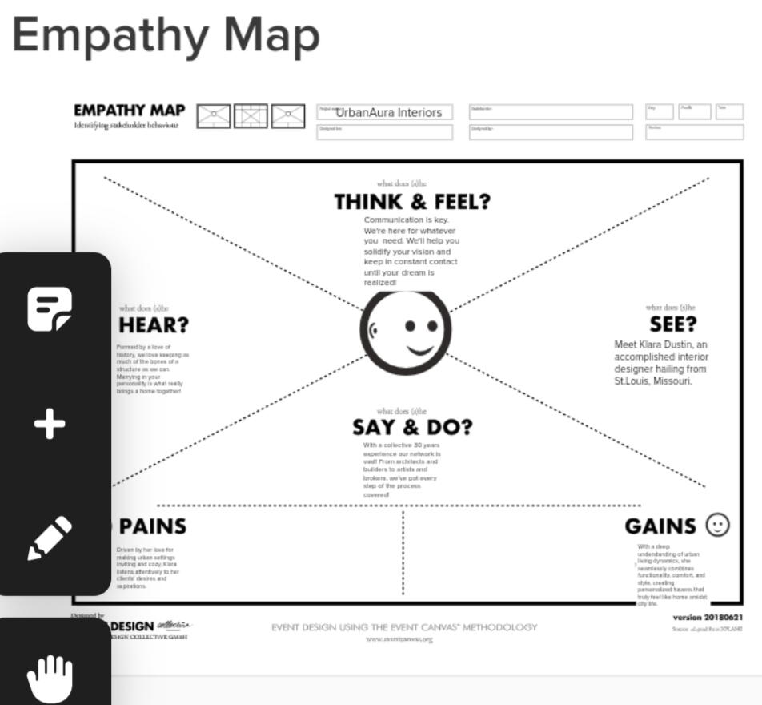

**2.2 Ideation and Brainstroming Map**

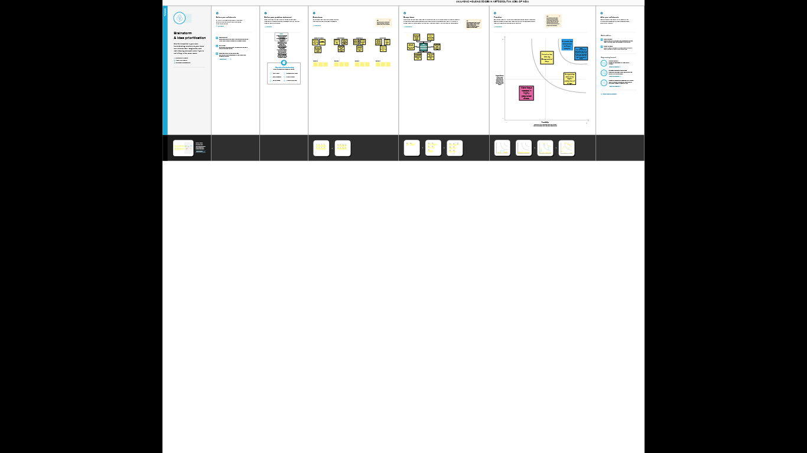

1. **Result:**
2. **Milestone 1: set up your account**
3. **Activity 1:sign up for a ZOHo books account and login**

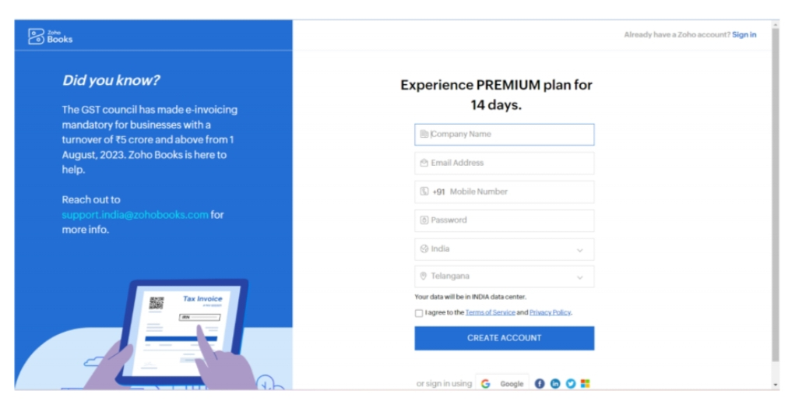

**Activity 2: introduction**

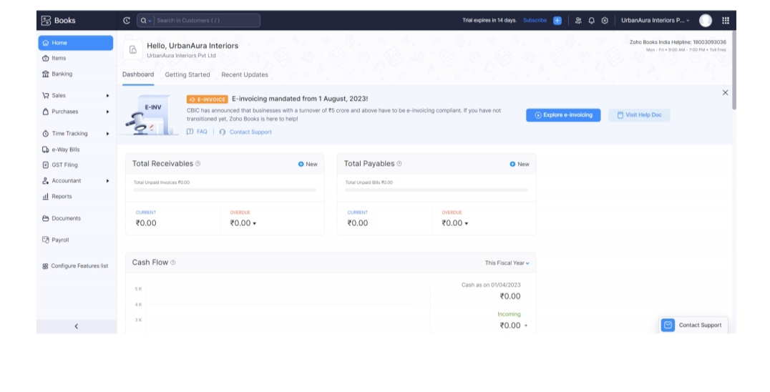

**Activity 3: Let's get started**

**Milestone 2:service creation :**

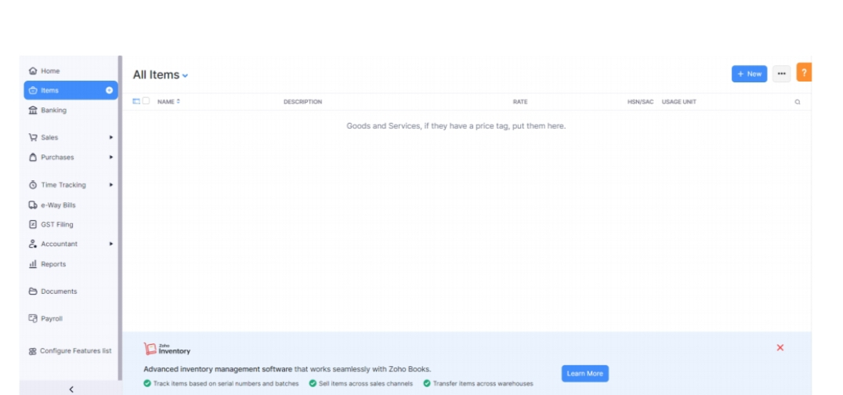

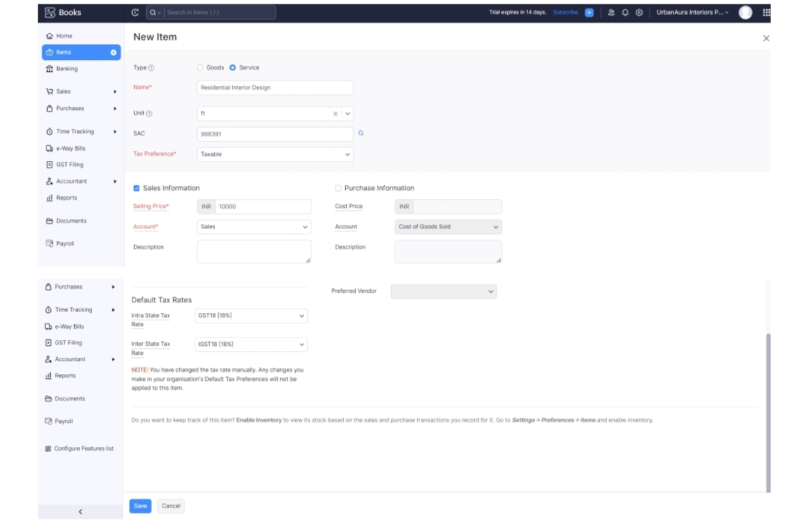

**Activity 2: Review for items after addition**

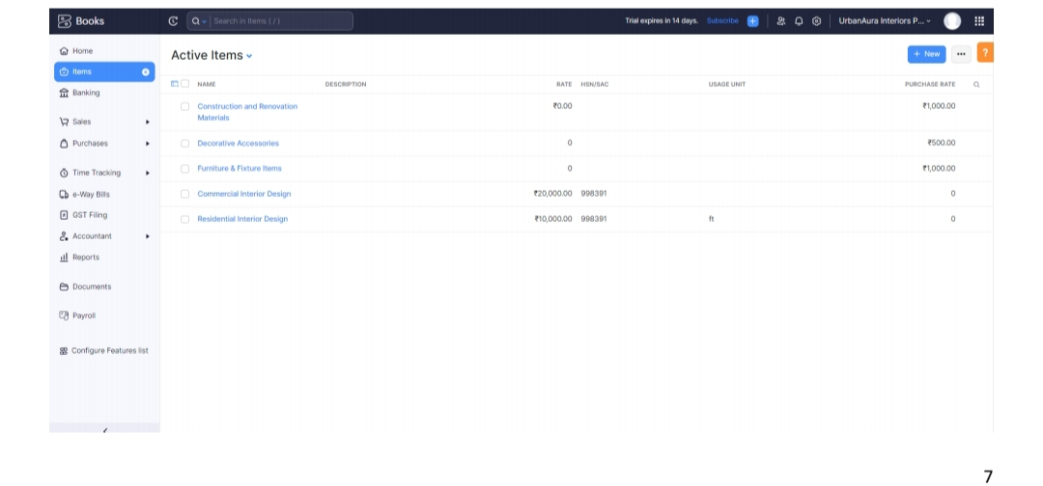

**Milestone 3:vendors**

**Activity 1: vendors creation**

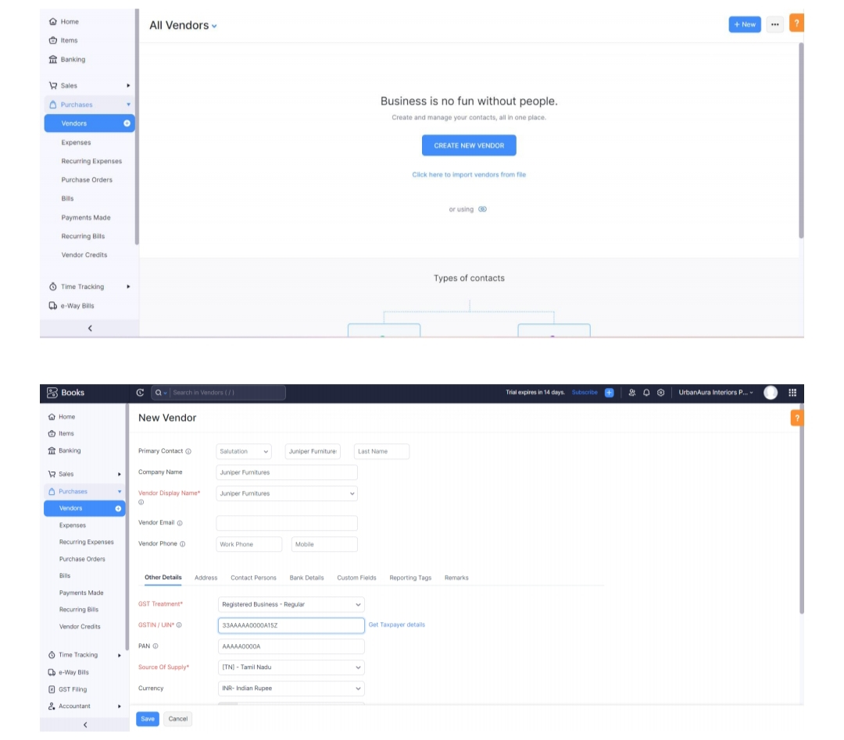

**Activity 2: Review of vendor list**

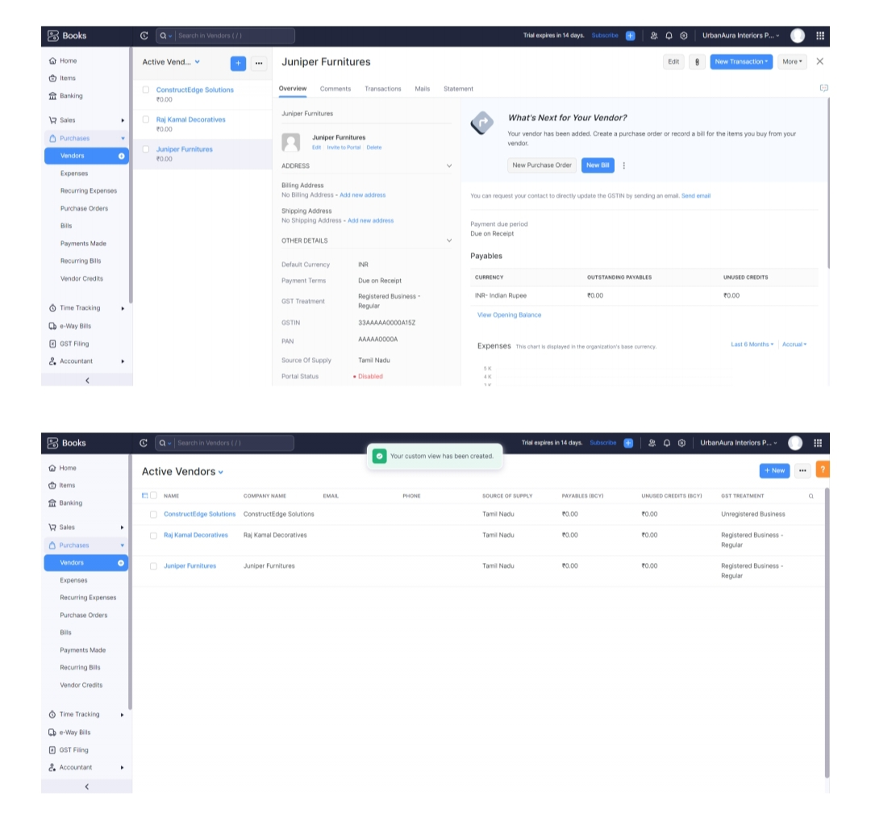

**Milestone 4: purchase**

**Activity 1: purchase order creation**

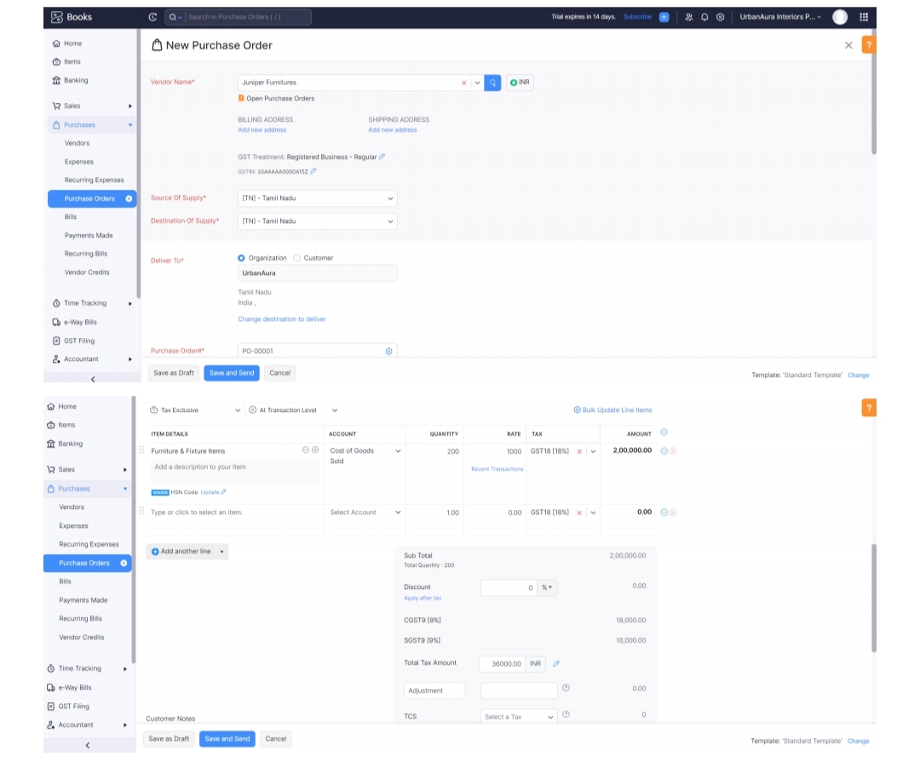

**Activity 2: purchase order to purchase bills convertion**

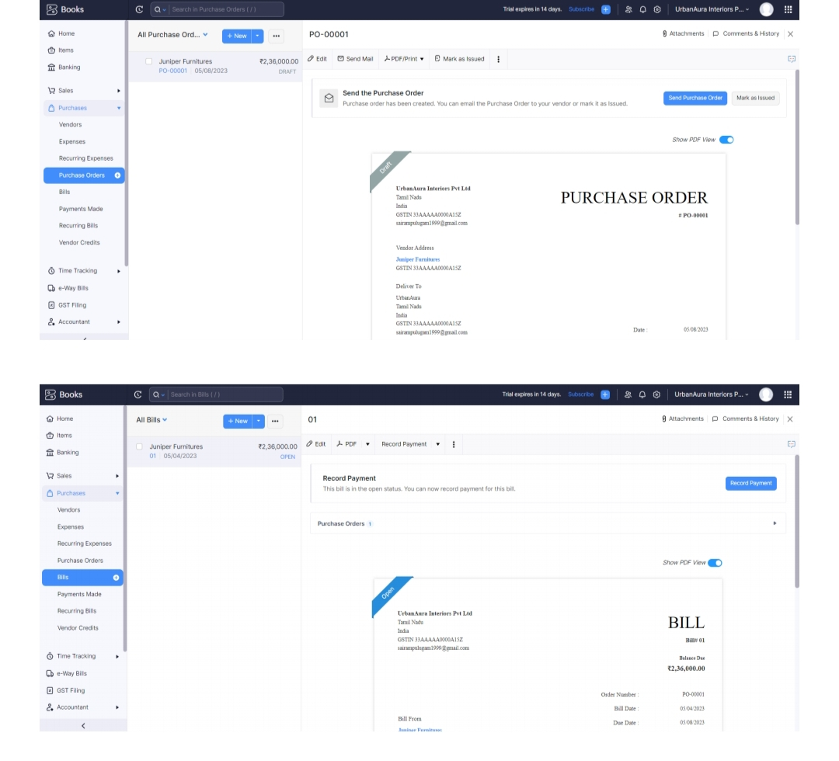

**Activity3: Direct vendors purchase bills creation :**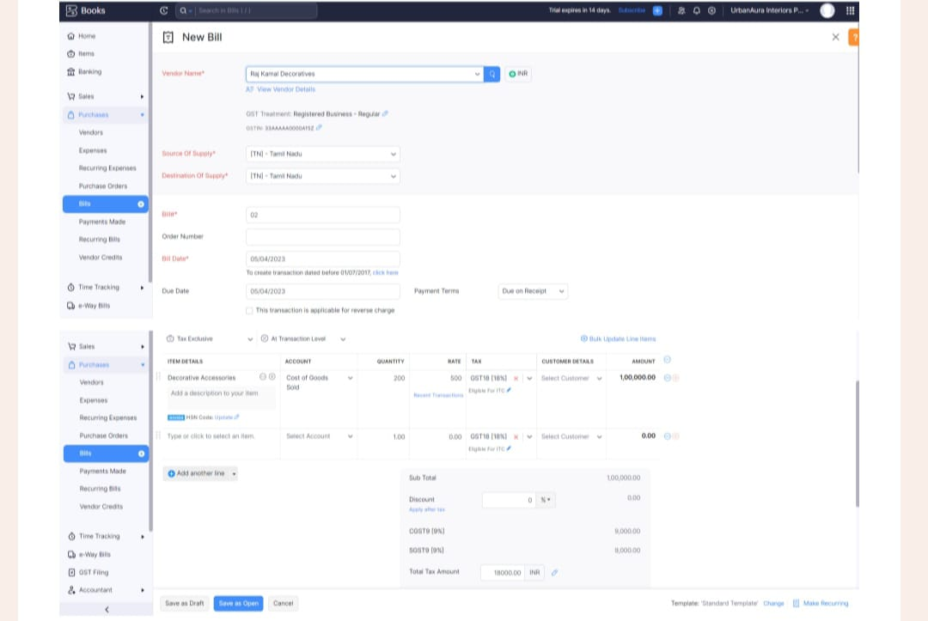

**Activity 4: Reconciliation of open & Outstanding bills**

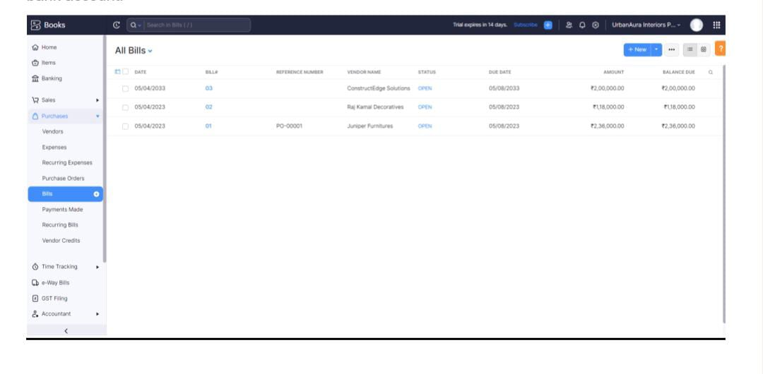

**Milestone 5: customes**

**Activity 1: customes creation:**

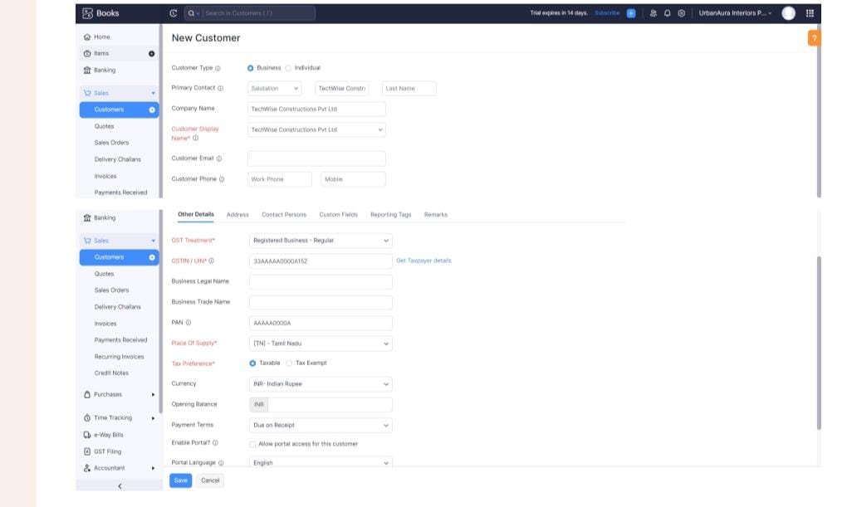

**Activity 2:Review the customes list**

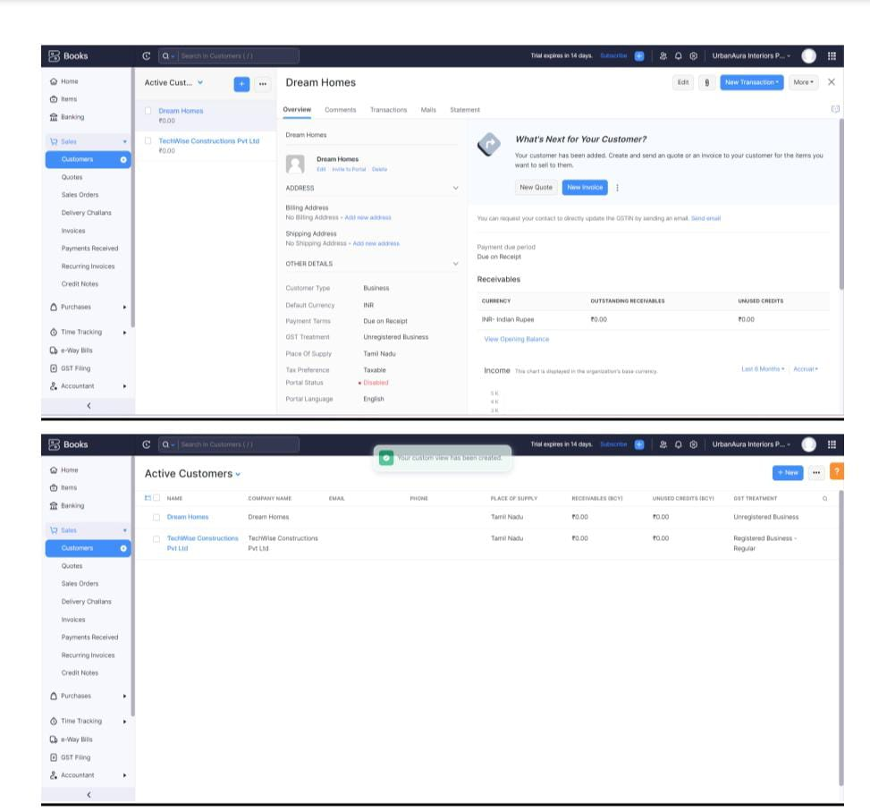

**Milestone 6:sales**

**Activity 1:sales order creation**

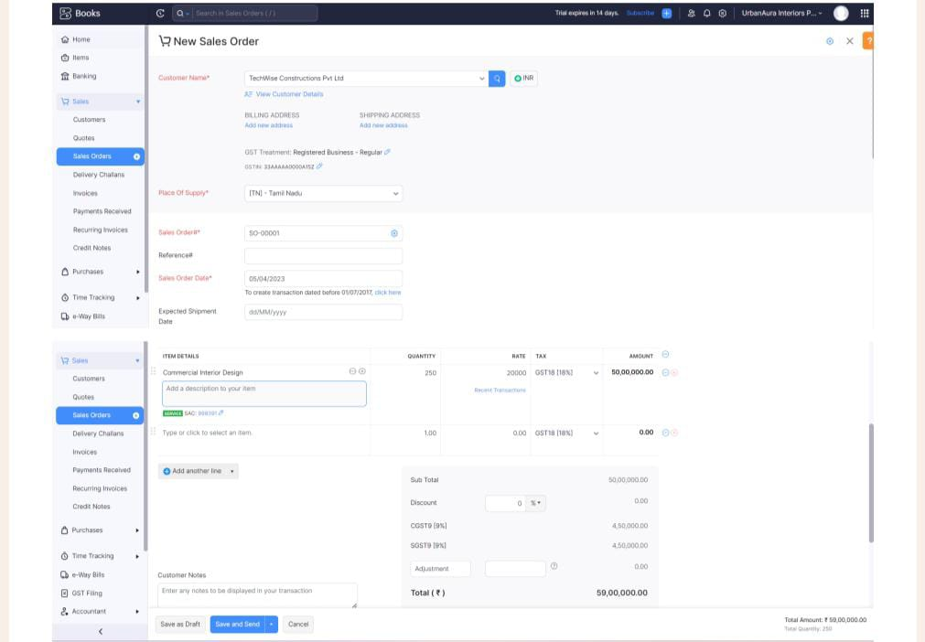

**Activity 2: Sales order to sales invoice convertion**

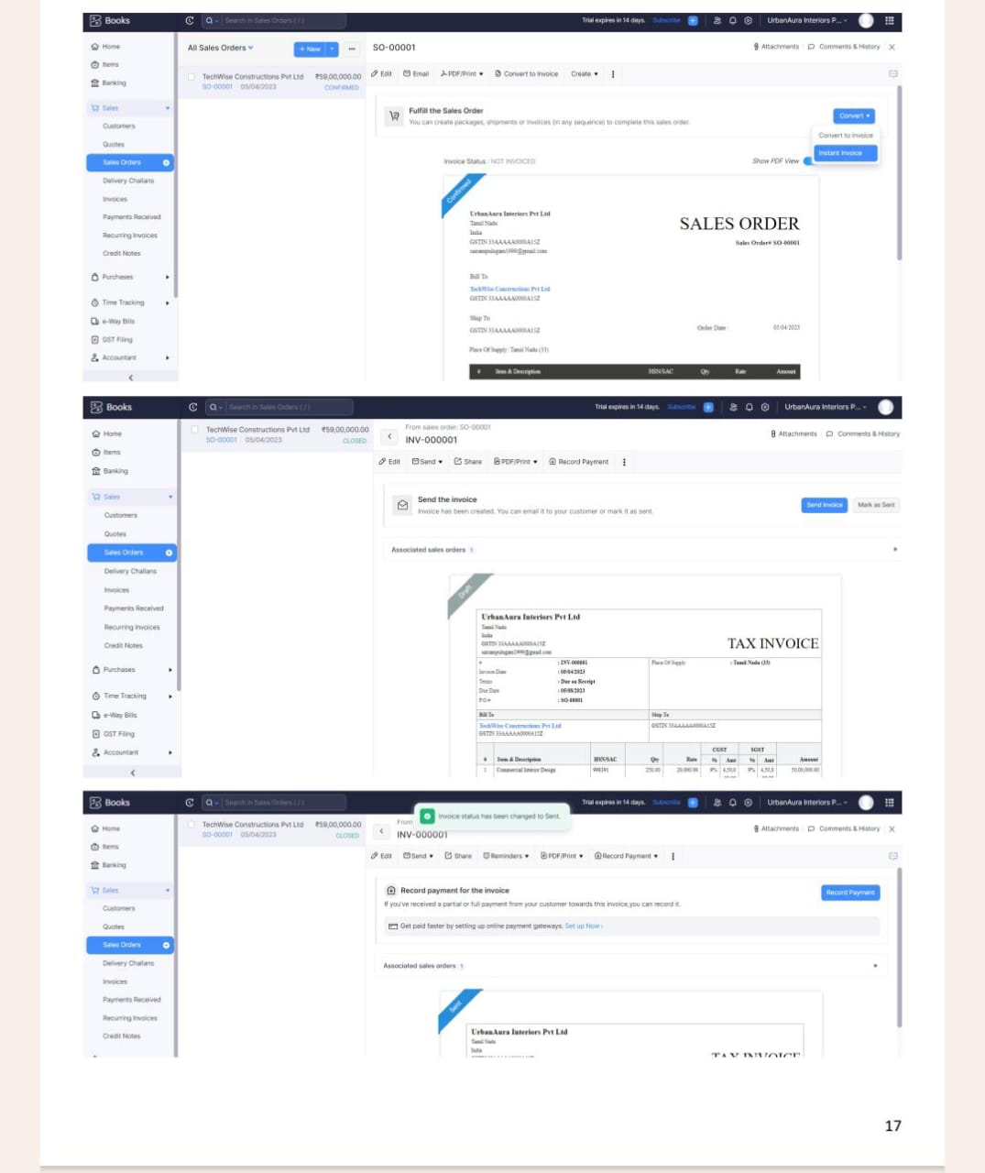

**Activity 3:Direct sale invoices**

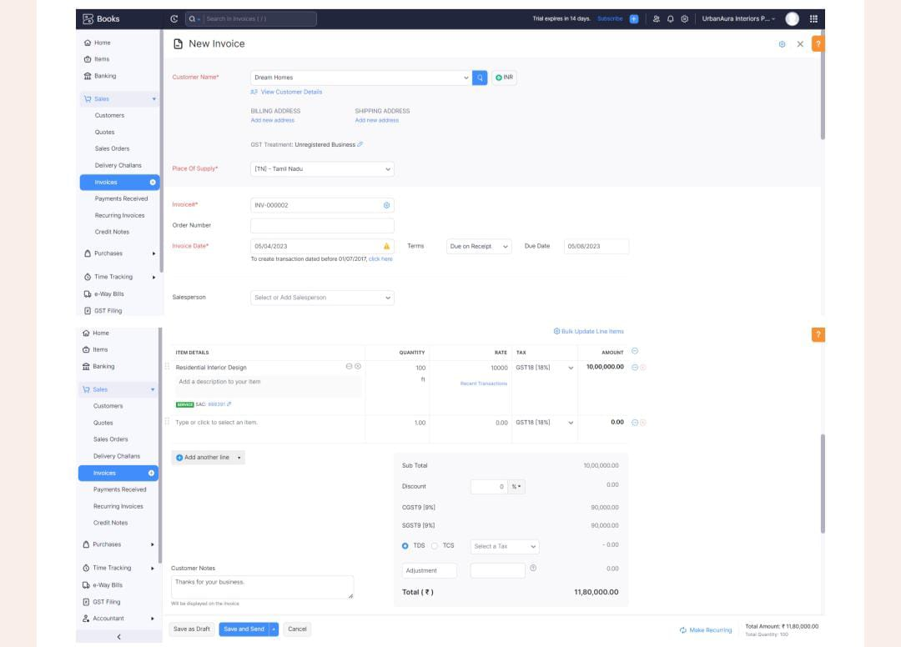

**Activity 5: Reconciliation of open invoices**

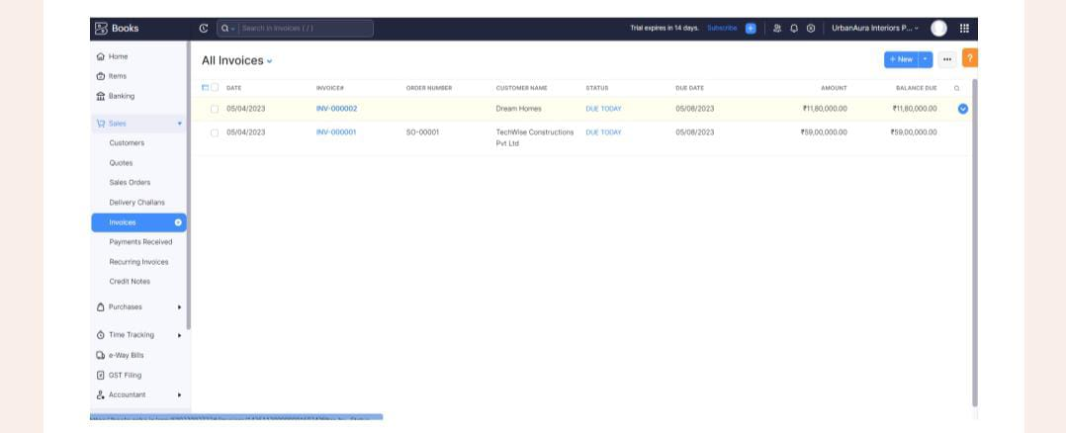

**Milestone 7:Bank account**

**Activity 1:Adding Bank account**

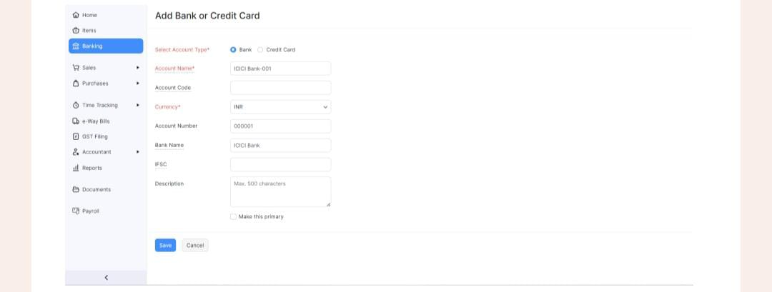

**Milestone 8: Accounts &ledgers**

**Activity 1: Creation of New Accouns /Ledgers:**

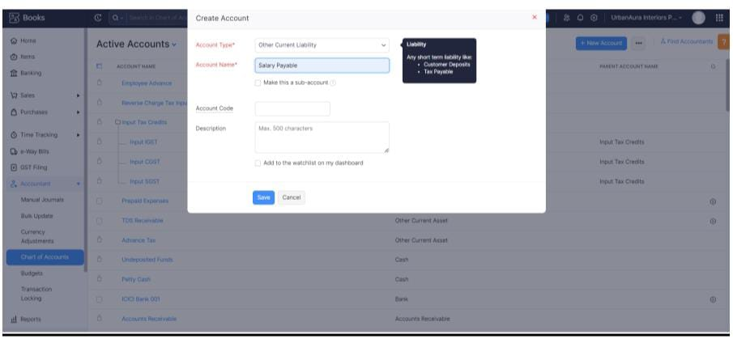

**Milestone 9:Journal Entries:**

**Activity 1:Recording of Journal Entries**

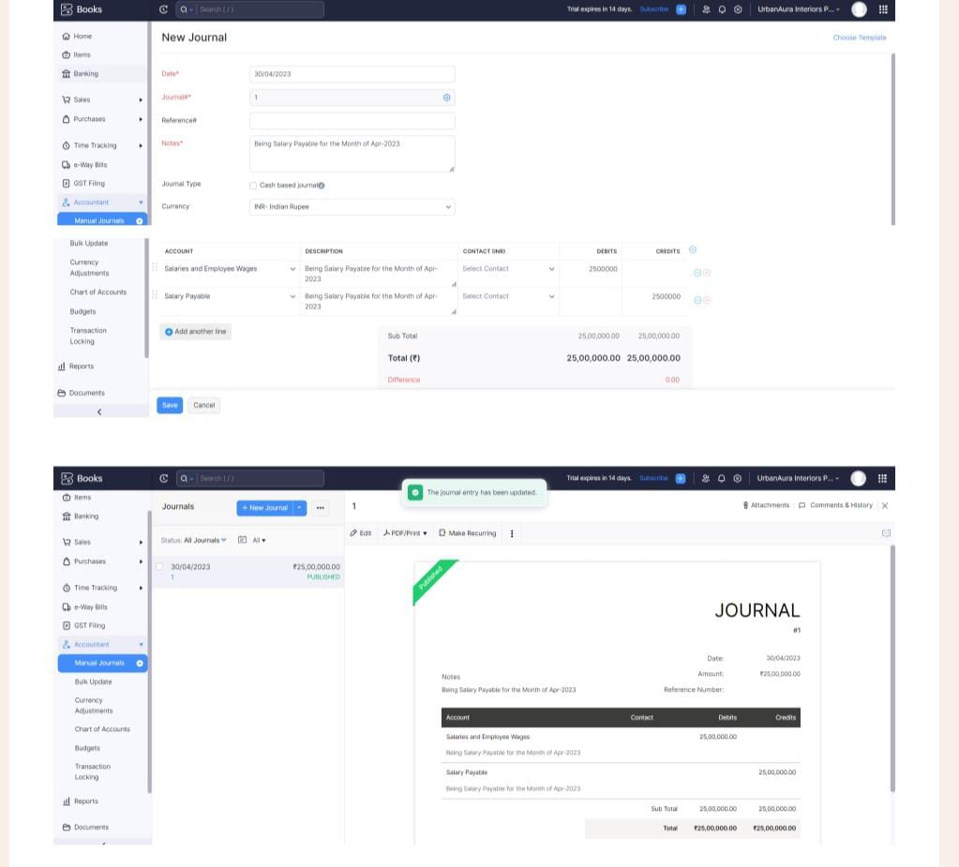

**Milestone 10: Expense&Bills**

**Activity 1: Expense &Bills Entry**

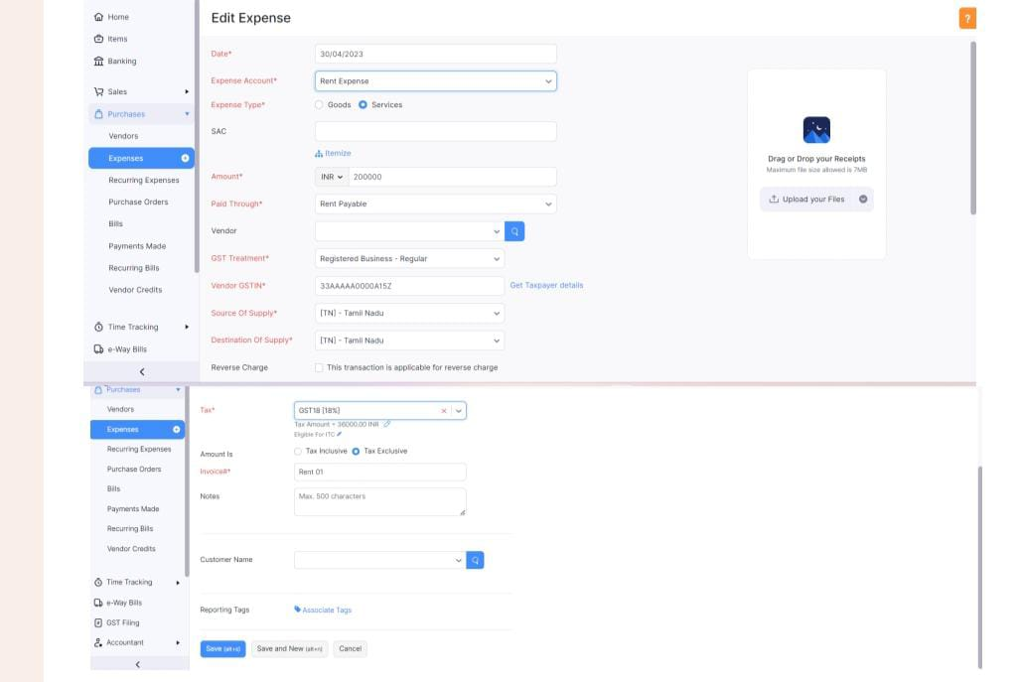

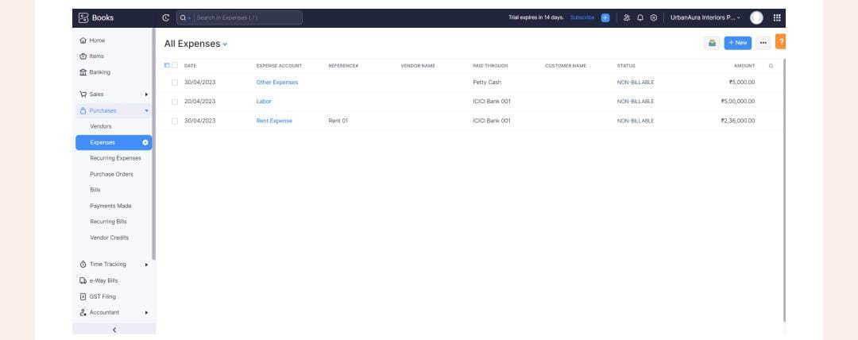

**Milestone 11:Bank Entries**

**Activity 1:Recording of Bank Transaction**

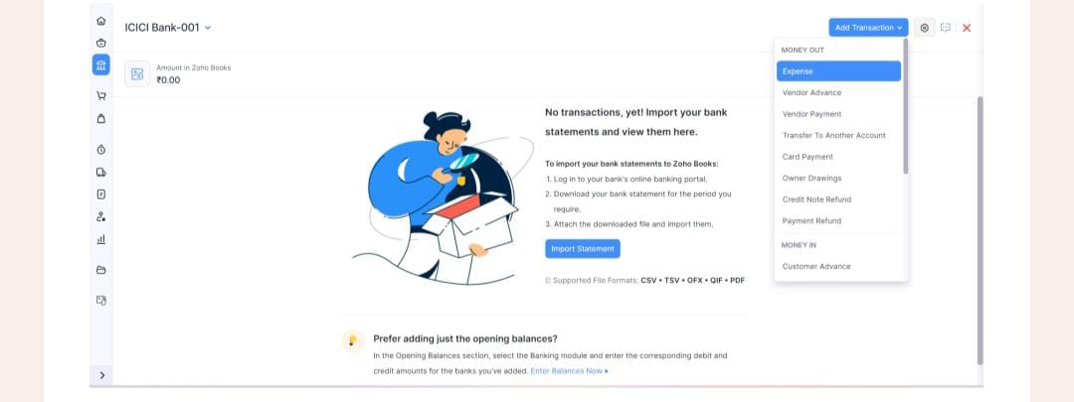

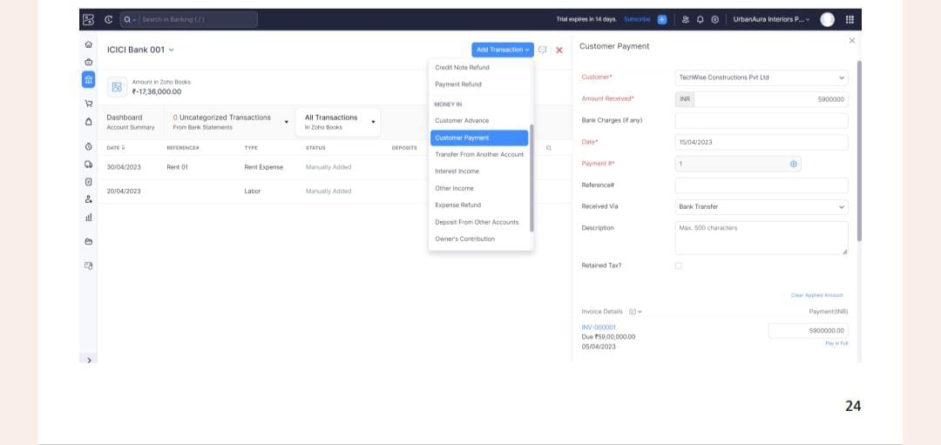

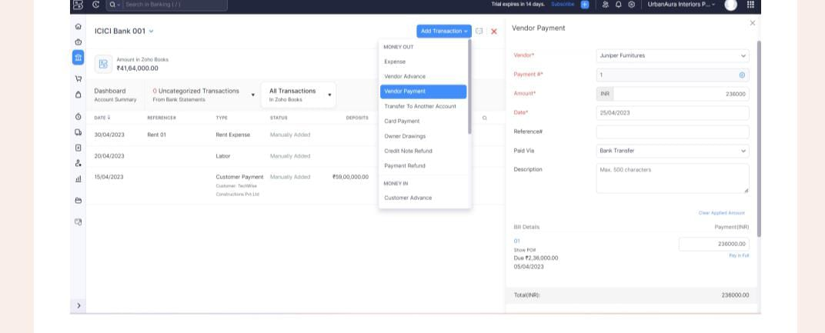

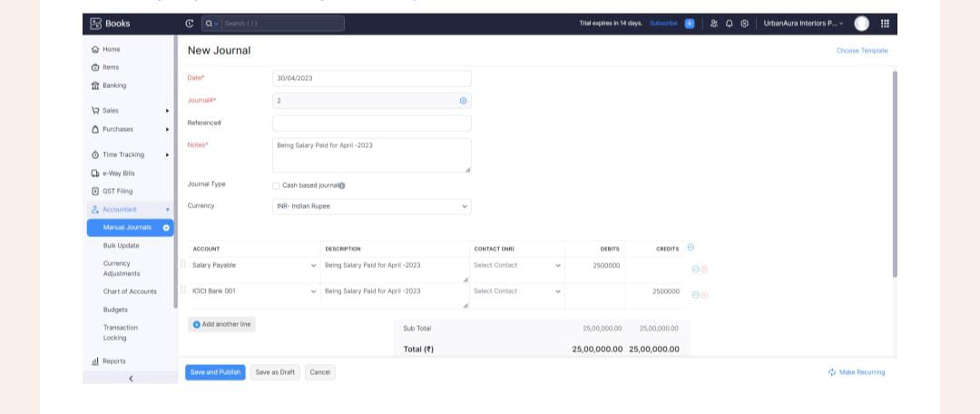

**Milestone 12: Financial Reports:**

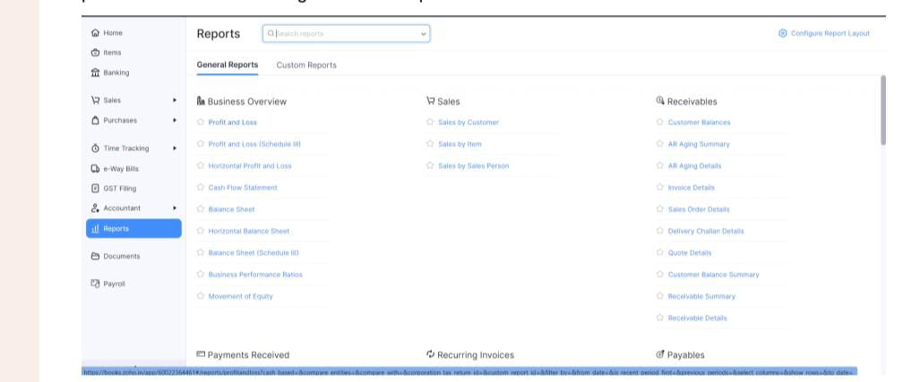

**:**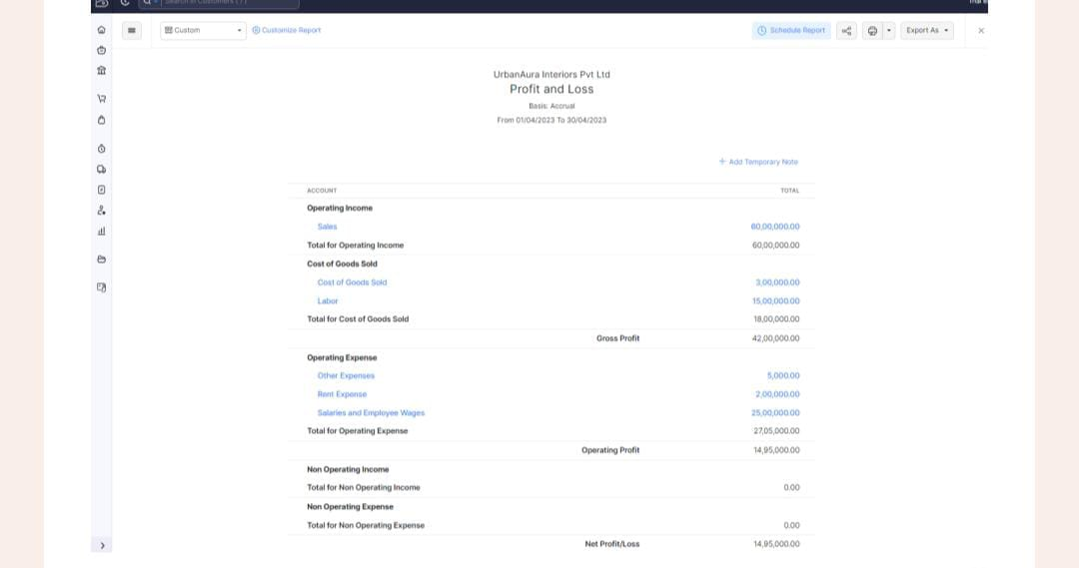

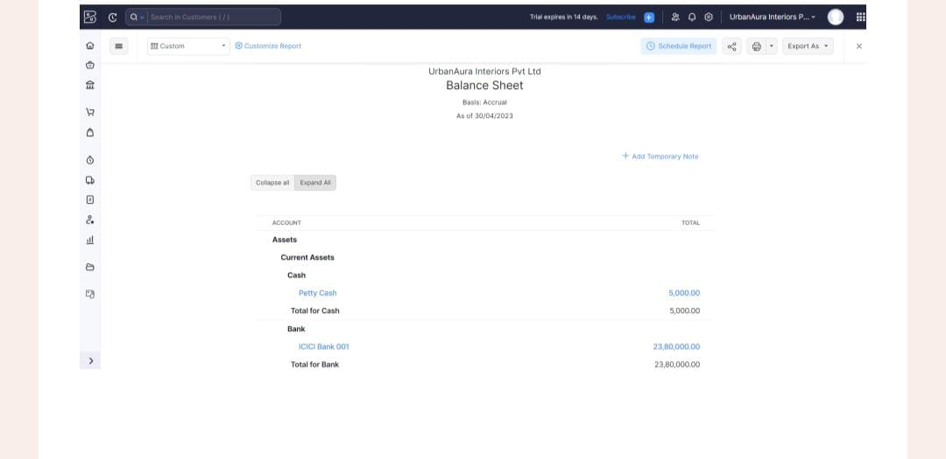

**Activity 3:GST Reports**

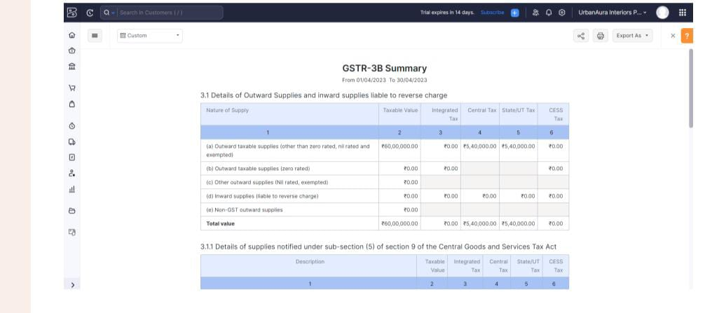

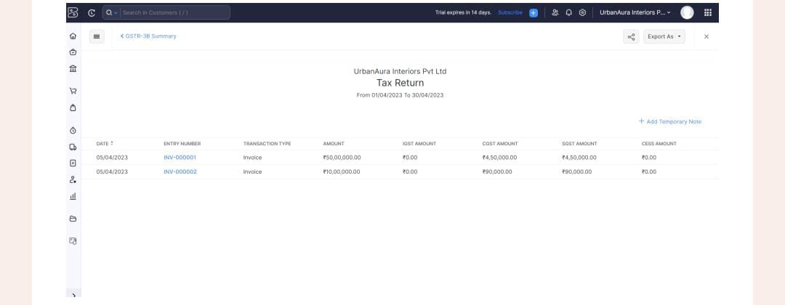

**Activity 4:Journal Report**

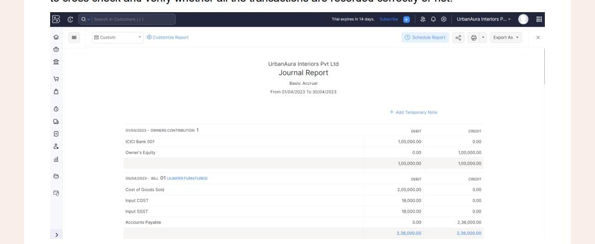

**Activity 5:Accounts Receivable Aging Details**

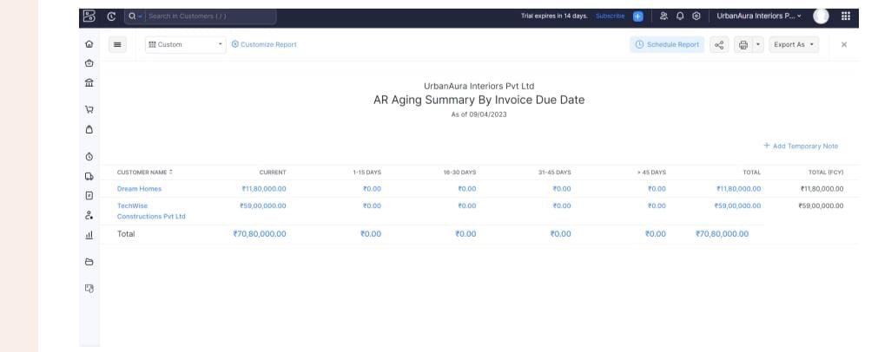

**:**

**Activity 6: Accounts Payable aging Details**

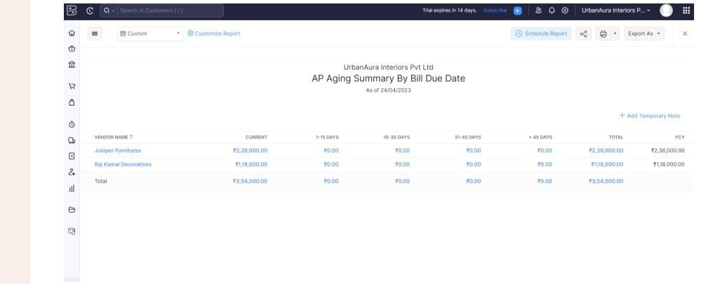

**Dashboard 3:**

**Story 2:**